idlForm

a FarCry plugin by IDLmedia

30. July 2007 – idlForm version 0.2

Trond Ulseth – IDLmedia AS

Introduction

IdlForm is a plugin primarily for use together with FarCry CMS. It will enable the administrators to add custom forms to their websites. Each form submission will be emailed to an address that is defined for each form, as well as being logged and available from the FarCry administration.

Installation

Put the idlForm directory in the plugins directory of the FarCry root directory.

- New applications: You should now be able to deploy idlForm as one of the plugins to install during the installation of a new FarCry application.
- Existing applications: It is also possible to add the plugin to an existing application. Open up the application.cfm file for the project. There's a farcry:farcryInit tag with plugins as one of the attributes, where the plugins in the project is listed as a comma delimited list. Add idlForm to the list. Refresh the application scope and log into the FarCry administration for the application. Choose the «Admin» tab, then «COAPI Management» from the select box menu, and click «Type Classes» from the menu. You should now see four new Custom Content Types. Click «Deploy» for all these

How to use

In the FarCry administrator right click on a navigation node in the site tree. Choose «Create» and then «Form»:

Fill in the details for the form (see screen shot below).

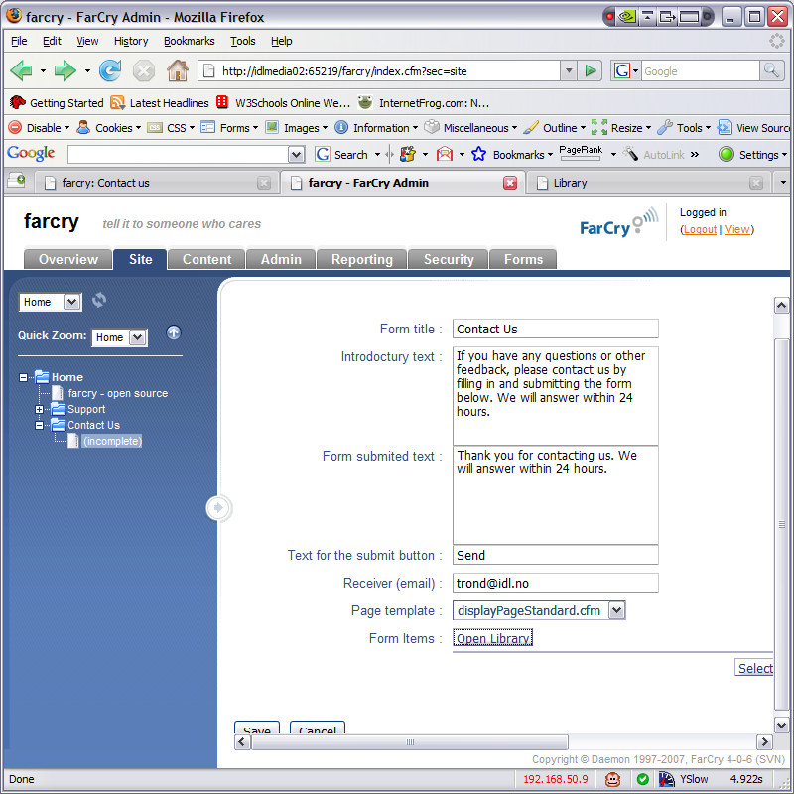

In order to add input fields to the form we click the «Open Library» button behind the «Form Items» label. We now get a new window.

All existing form item elements are displayed at the right – you can drag these over to the left to add them to the newly created form. You create new form elements by clicking the «Add New» tab.

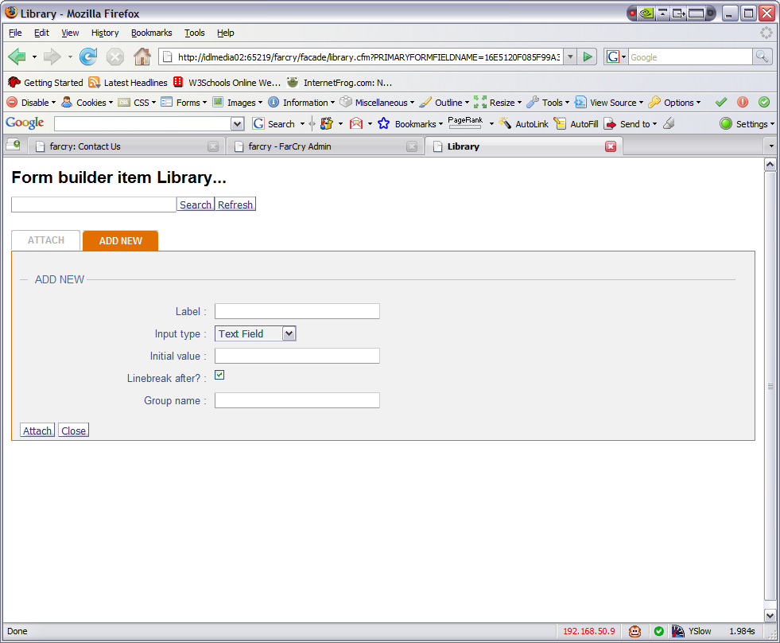
Label is the text that will be displayed in front of the input field.

Input type give you the choice of the following:

Text field
Text area
Radio Button
Check box
List
Attachment
Static text

Initial value – will display the text you type in for text field, text area and static text. For radio buttons and check boxes you type in «1» if they should be checked by default.
For a list, you make a comma separated list for the different options.

Line break after – by not selecting these you can have input elements in one line.

Group name – used to group check boxes and radio buttons in groups.

Close the library window and save the form. On the site you should now see something like this:

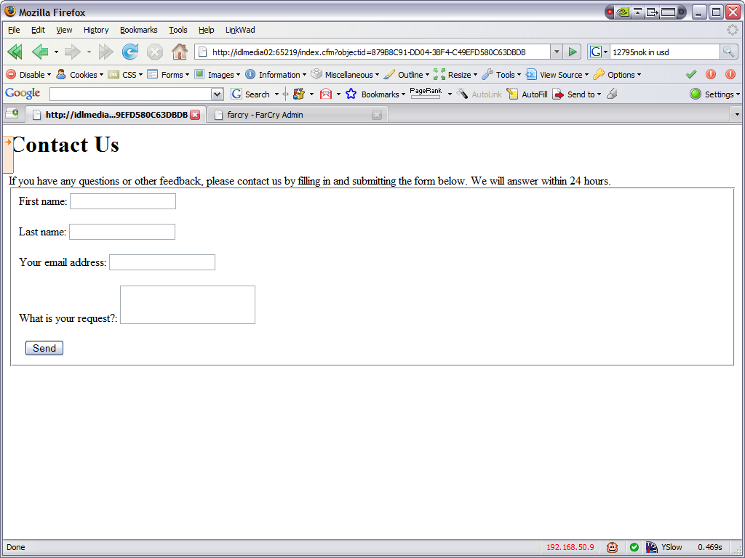

Make it pretty!

To make this a bit make a new folder in the webskin folder of your project directory called «idlForm» and then make a new file called «displayPageStandard.cfm». Make it a template that imports the displayPageStandard.cfm from the idlForm plugin folder. It could look something like this:

<cfsetting enablecfoutputonly="yes">
<!--- header --->
<cfmodule template=
"/farcry/projects/#application.applicationname#/webskin/includes/dmHeader.cfm" layoutClass="type-a" pageTitle="#stObj.title#">

<cfoutput><div id="content"></cfoutput>

<cfinclude template=
"/farcry/plugins/idlform/webskin/idlform/displayPageStandard.cfm">

<cfoutput></div></cfoutput>

<!--- footer --->
<cfmodule template=
"/farcry/projects/#application.applicationname#/webskin/includes/dmFooter.cfm">
<cfsetting enablecfoutputonly="no">

Update your application scope and you should see something like this:

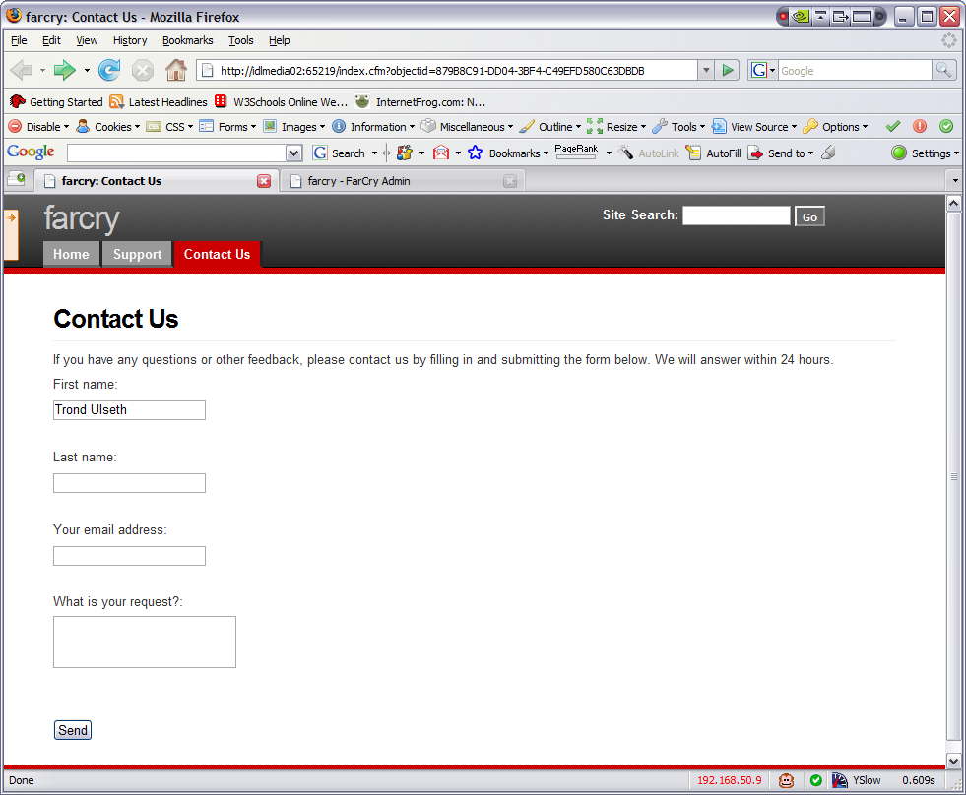

Under the Forms tab

In the administrator you might also have noticed the new «Forms» main tab. By clicking this we get two options. «Forms» will list up all the forms we have in use on our site – and also gives us the option to edit these. We can also edit them directly from the site tree.

The other option is «Form log». This is a list over all the form submtions from your site.

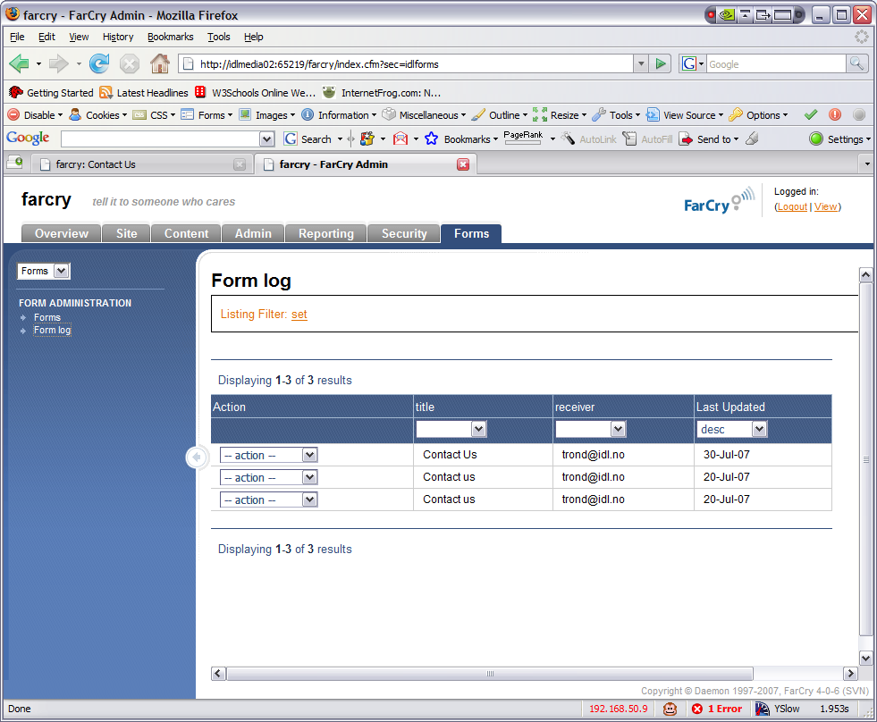

And you can of course view the full details of any submission:

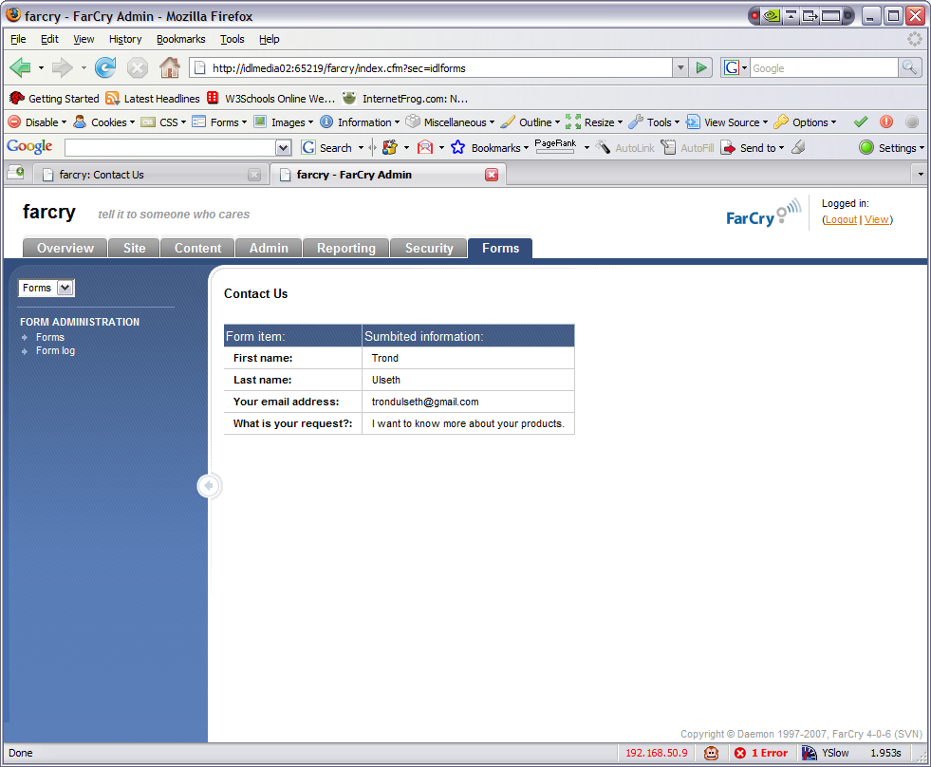

Using idlForm as a rule

As of version 0.3 you can use idlForm as a container rule. I've created another page below called «Contact Us 2» and clicked «Show design» in the FarCry menu (the one that appears when you click the orange square with the arrow on the top left).

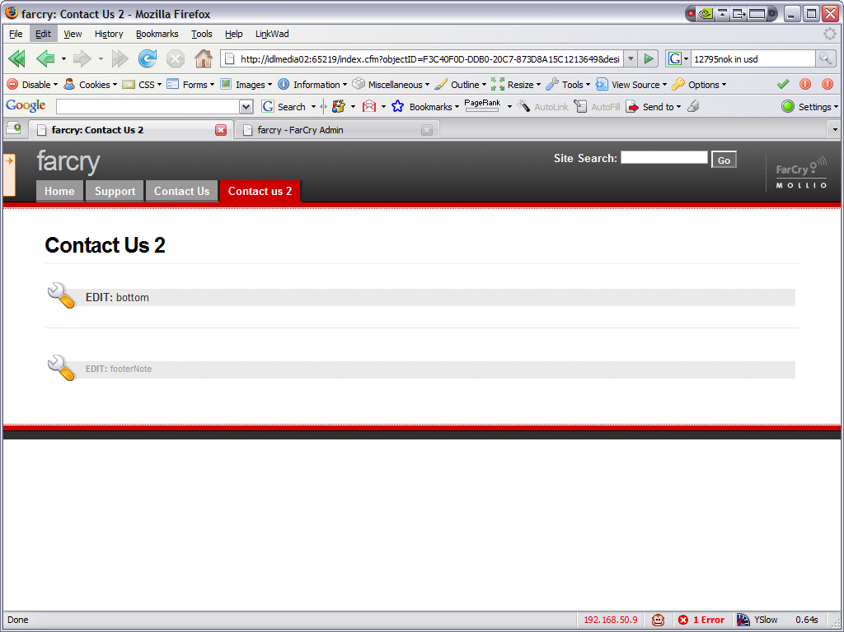
I then click on the «EDIT: bottom» container menu.

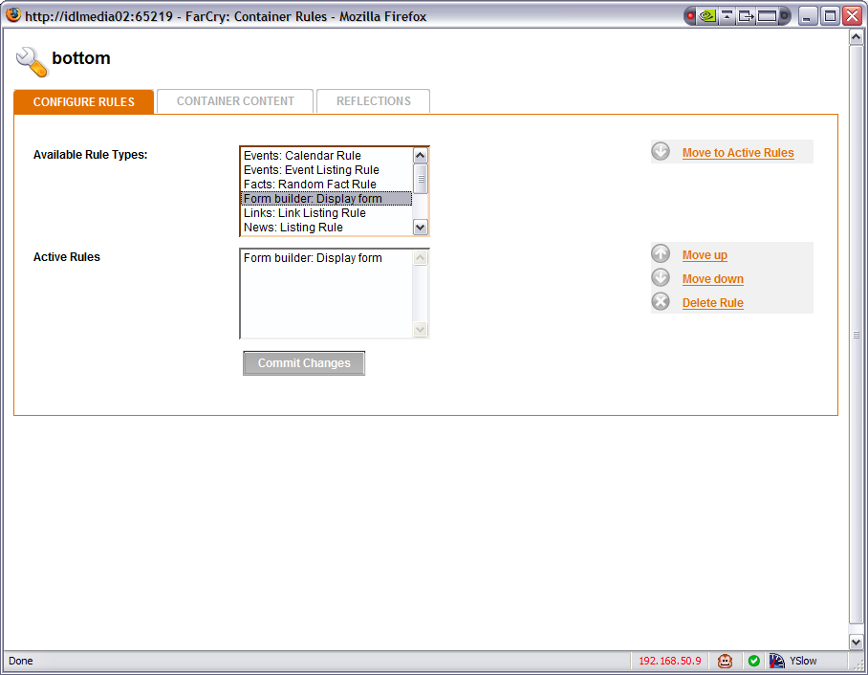
In the window that pops up we see that one of the available rule types are «Form builder: Display form». So let's choose it and click «commit changes». We then see this:

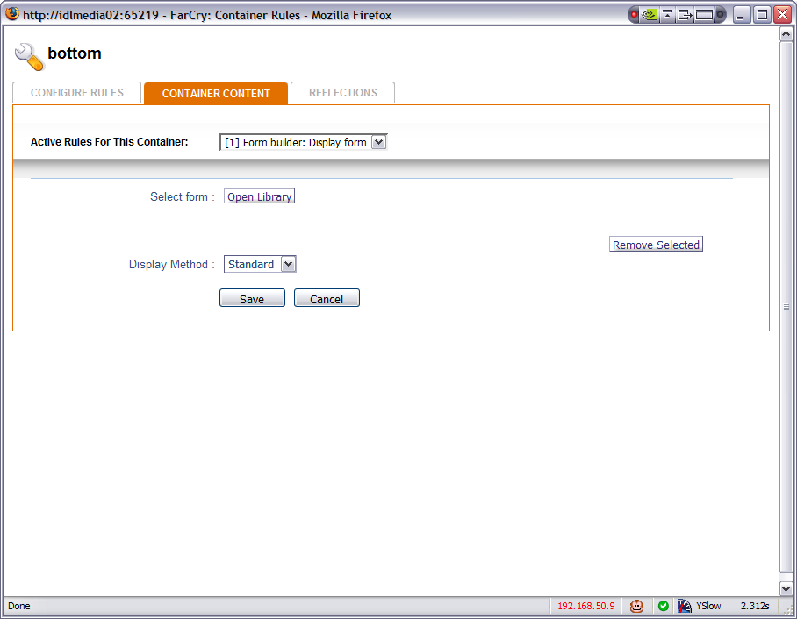
Click on Open Library and you'll see this:

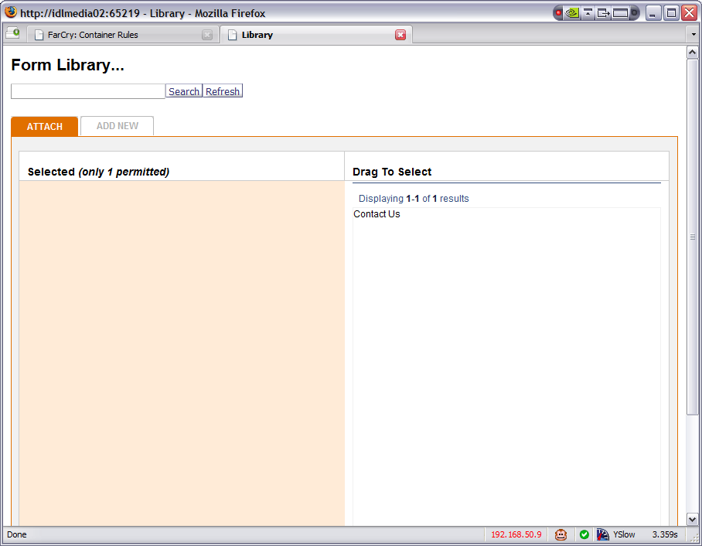
We see here that we can select to display the form that we have already created or we can also use the Add New tab to create a new form as we have described above.

Now I'll only use the existing form and I end up with this:

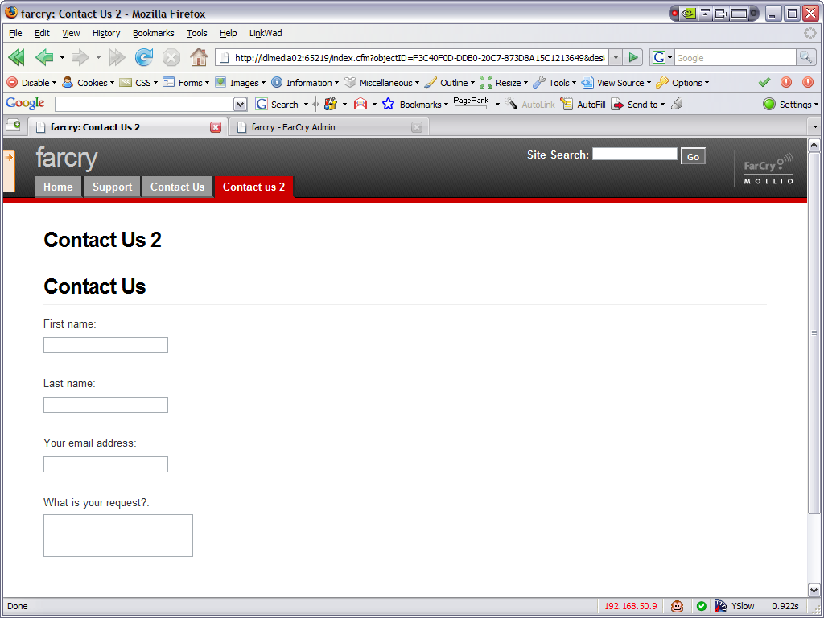
You'll notice that the title of the form is displayed as a header (h1). You can either use css to make this look as you want, or copy the displayRuleStandard.cfm file from the idlForm/webskin/idlForm plugin directory and save it into the webskin/idlForm directory of the project (the one we created when making the form pretty above) and modify as you like (remember to update your application scope).

The end

This plugin is open-source under the Apache License, Version 2.0 . You can use it and modify it as you wish. We do not guarantee that it is bug free and don't accept any responsibility for your use of it.

We plan on enhancing the plugin further. If you have any good ideas or would like to help, contact me at trond@idl.no

